2025

GHANA BOOK DEVELOPMENT COUNCIL (GBDC)

Document Number: <GBDC/RTI/2025> Subject to Revision by GBDC
Government of Ghana

Right to Information Manual Template

Table of Contents
Table of Contents…………………………………………………………………………………..........i
1. Overview 1
2. Directorates and Departments under Ghana Book Development Council 2
2.1 Description of Activities of each Directorate and Department 3
2.2 Ghana Book Development Council’s Organogram 7
2.3 Classes and Types of information 8
3. Processing and Decision on Application – S. 23 9
4. Amendment of Personal Record 10
4.1 How to apply for an Amendment 10
5. Fees and Charges for Access to Information 11
6. Appendix A: Standard RTI Request Form 12
7. Appendix B: Contact Details of GBDC’s Information Unit 15
8. Appendix C: Acronyms 16
9. Appendix D: Glossary 17

Overview
This Right to Information Manual (‘The Manual’) seeks to make available to the public and applicants for information the classes of information accessible in this institution. It reveals the various departments and structures within this institution and specific classes of information that can be obtained from each of them.

The Manual has been compiled in compliance with section 3 of the Right to Information Act, 2019 (Act 989). Inspection of this Manual is not to attract any fee or charge since the Manual only seeks to point users to the information available for access within the institution. Request for a copy of this Manual, however, shall attract a charge which covers the unit cost of the Manual.

1.1 Purpose of Manual – To inform/assist the public on the organizational structure, responsibilities and activities of the Ghana Book Development Council (GBDC) and provide the types or classes of information and classes of information available at GBDC, including the location and contact details of its information officers and units.

Directorates and Departments under Ghana Book Development Council
This section describes the institution’s vision and mission and lists the names of all Directorates and Departments under the institution, including the description of organizational structure, responsibilities, details of activities and classes and types of information accessible at a fee.
VISION
To nurture and develop an indigenous and vibrant Book Industry for a functionally literate society.

MISSION
To stimulate and coordinate the publication and use of books in such a manner that they become effective tools for national development, and integrate book promotion plans with the overall national development planning.

Directorates and Departments under Ghana Book Development (GBDC)
1. Literacy Promotion
2. Operations
3 Research, Monitoring and Evaluation
4. General Administration
5. Finance
Responsibilities of the Institution:

- Plan and coordinate public and private entities interested in book development.
- Promote reading habits among Ghanaians, particularly school children.
- Promote the development of indigenous authors and translation of books by indigenous authors into Ghanaian languages.
- Promote distribution of books in the country.
- Promote and coordinate distribution of books authored by Ghanaians internationally.
- Establish standards for publishers and printers in the book industry.
- Bring together stakeholders to ensure collaboration, development, and conducive environment for the building of a strong book industry.
- Carry out comprehensive studies and research programmes essential for the development of the book industry.

2.1 Description of Activities of each Directorate and Department
Directorate/Department | Responsibilities/Activities
Literacy Promotion | - Provide inputs for formulation of policies of the Council  - Coordinate the development of operational work plan for the department  - Provide inputs for resource mobilization  - Coordinate the implementation of policies on literacy promotion  - Coordinate the development and implementation of programmes and activities on translation and reading  - Facilitate the production of braille reading materials  - Provide input for the development of indicators for monitoring and evaluation of the programmes and activities of the department  - Ensure the effective and efficient management of resources (human, material and financial) of the department  - Ensure the preparation and submission of annual departmental budget  - Ensure the preparation and submission of annual and other periodic departmental reports  - Develop a strong and effective team within the department  - Ensure the implementation of performance management policy in the department
Operations | - Provide inputs for formulation of policies of the Council  - Coordinate the development of operational work plan for the department  - Provide inputs for resource mobilization  - Coordinate the implementation of policies on operational services  - Coordinate the efficient and effective management of operational services in accordance with approved standards  - Coordinate the production and distribution of books, locally and internationally, in accordance with approved standards  - Provide input in development of indicators for monitoring and evaluation of the programmes and activities of the department  - Ensure the effective and efficient management of resources (human, material and financial) in the department  - Ensure the preparation and submission of annual departmental budget  - Ensure the preparation and submission of annual and other periodic departmental reports  - Develop a strong and effective team within the department  - Ensure the implementation of performance management policy in the department
Research, Monitoring and Evaluation | - Provide inputs for formulation of policies of the Council  - Ensure the effective and efficient management of resources (human, material and financial) in the department  - Coordinate the development of operational work plan for the department  - Provide inputs for resource mobilization  - Coordinate the development and management of appropriate systems, targets, tools and performance indicators that are in tandem with expected goals/objectives of the Council  - Ensure the monitoring and evaluation of the programmes, projects and activities of the Council  - Collaborate with stakeholders in the monitoring and evaluation of activities of the Council  - Ensure the assessment of economic and social impact of book production and distribution in Ghana  - Ensure the conduct of research in the Book industry  - Ensure timely preparation and submission of research, monitoring and evaluation reports  - Ensure the development and maintenance of database for the book industry  - Ensure the preparation and submission of annual departmental budget  - Ensure the preparation and submission of annual and other periodic departmental reports  - Develop a strong and effective team within the department  - Ensure the implementation of performance management policy in the department
General Administration | - Provide inputs for formulation of policies of the Council  - Coordinate the development of work plan of the Department  - Provide inputs for resource mobilization for the Council  - Ensure the preparation and submission of annual departmental budget  - Coordinate the preparation and submission of annual and other periodic reports of the Council  - Coordinate the implementation of performance management policy of the Council  - Coordinate plans to ensure the availability of resources to support the activities of the Council  - Coordinate the development of guidelines and procedures for the administration and management of logistics  - Coordinate the development and management of ICT infrastructure for the Council  - Coordinate the preparation and implementation of procurement plans of the Council  - Coordinate the organisation of all meetings, seminars, workshops and conferences of the Council  - Leads the development of human resource systems, guidelines and procedures for the Council  - Provide advisory services on all aspects of the labour law, regulations and practices, to ensure that all HR requirements and best practices are maintained  - Lead the implementation of human resource activities including recruitment, promotion, posting, training, welfare, career development and succession planning of the Council
Finance | - Provide inputs for formulation of policies of the Council.  - Coordinate the development of operational work plan for the department  - Ensure the development of financial proposals for mobilising resources for the Council  - Ensure the effective and efficient management of resources (human, material and financial) in the department  - Advise management on Financial Administration Act and its Regulations, Internal Audit Agency Act, Procurement Act, and any other financial regulations approved by the Government  - Ensure the timely preparation and submission of statutory and periodic financial reports of the Council  - Ensure the judicious use of funds in accordance with financial regulations  - Develop guidelines and procedures for financial management  - Coordinate the preparation of annual budget of the Council  - Co-operate with external auditors for the auditing of the financial statements  - Take timely action on financial recommendations contained in audit reports  - Develop a strong and effective team within the department  - Develop and maintain effective and efficient consultation with all departments within the Council  - Ensure the implementation of performance management policy in the department  - Ensure the preparation and submission of annual and other periodic departmental reports

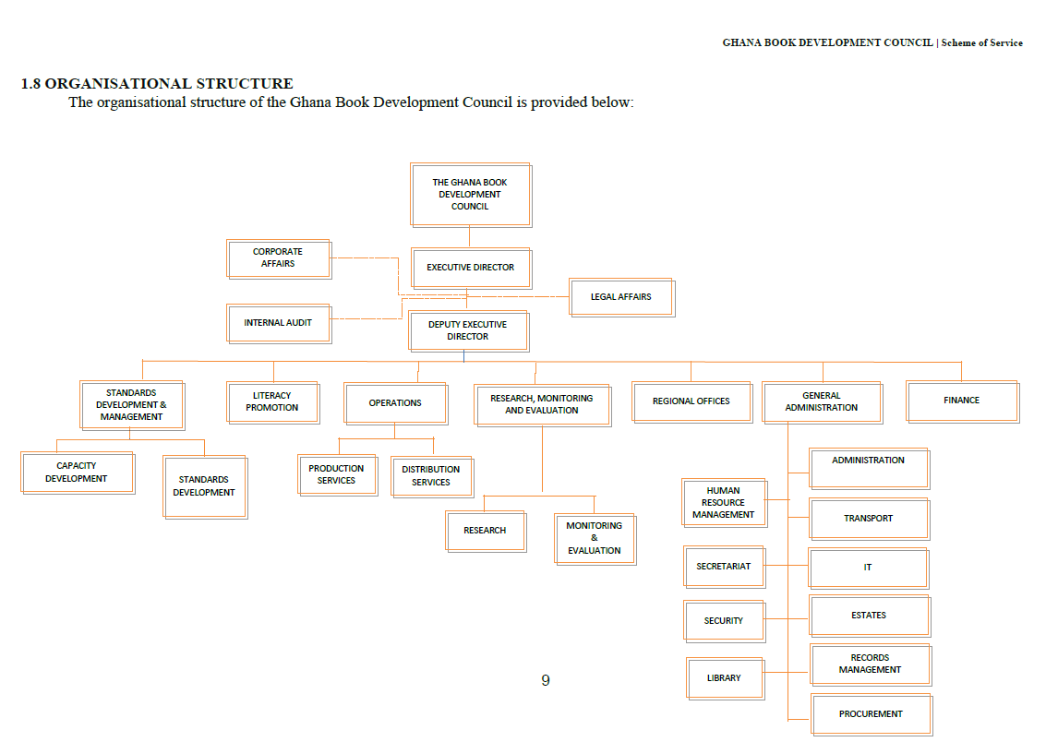
2.2 Ghana Book Development Council’s Organogram

2.3 Classes and Types of information

List of various classes of information in the custody of the institution:
- Literacy Promotion
- Operations/General services
- Finance

Types of Information Accessible at a fee:

Processing and Decision on Application – S. 23

1
2
3
Application made under s.18 is submitted to the Information Unit of the Public Institution
The RTI officer or designated RTI Officer shall upon receipt of the application make a determination as to whether or not the application is one that safeguards the life or liberty of a person within the ambit of s. 23 (7)
4
5
6
Where the application does not fall within the ambit of s. 23 (7), the RTI Officer shall within 14 days of receiving the request, engage the relevant persons within the institution and the information generating directorate to confirm the availability of the information requested
Where an EXTENSION of time is needed, RTIO shall comply with S. 25.
IF NOT,
Notice of the Decision shall be communicated to the Applicant by or on the 14th working day from when the application was made.
The Decision shall where it confirms the availability of information state the manner in which access will be granted and whether or not access to the information shall be given in part and the reasons for giving only part. (s. 23(1)(2)(3).
Where the information requested shall be refused, the RTIO shall notify the applicant within 14 days of receiving the application, communicating the refusal of the application and the reason for the refusal. Where it falls within the exempt category s.5-17; s.23 (10);s.24; the RTIO shall state the section/reason the refusal was based.

RTIO: Right to Information Officer

Amendment of Personal Record
A person given access to information contained in records of a public institution may apply for an amendment of the information if the information represents the personal records of that person and in the person’s opinion, the information is incorrect, misleading, incomplete or out of date.

4.1 How to apply for an Amendment
- The application should be in writing addressed to the head of the public institution indicating;
- Name and proof of identity.
- Particulars that will enable the records of the public institution identify the applicant
- The incorrect, misleading, incomplete or the out of date information in the record.
- Signature of the applicant
- For incomplete information claimed or out of date records, the application should be accompanied with the relevant information which the applicant considers necessary to complete the records.

- The address to which a notice shall be sent should be indicated.

- The application can then be submitted at the office of the public institution.

- A statutory declaration must be attached.

Fees and Charges for Access to Information

The Act mandates Parliament in Section 75 to approve a fee that public institutions can charge. However, fees shall apply to only the three circumstances stated below:
- Request for information in a language other than the language in which the information is held. (s.75) (3).

- When request is made for a written transcript of the information, the Information Officer may request a reasonable transcription cost (s.75) (4).

- Cost of media conversion or reformatting. (s.75) (5).
Under Section 75 (2), fees are not payable for:
- reproduction of personal information
- information in the public interest
- information that should be provided within stipulated time under the Act
- an applicant who is poor or has a disability
- time spent by the information officer in reviewing the information
- time spent by the information officer to examine and ensure the information is not exempt
- preparing the information

Appendix A: Standard RTI Request Form
[Reference No.: ………………………….]

APPLICATION FOR ACCESS TO INFORMATION UNDER THE RIGHT TO INFORMATION ACT, 2019 (ACT 989)

 | Name of Applicant:
2. | Date:
3. | Public Institution:
4. | Date of Birth: |  | DD |  |  | MM |  | YYYY
5. | Type of Applicant: |  | Individual Organization/Institution
6. | TIN Number
7. | If Represented, Name of Representative:
7 (a). | Capacity of Representative:
8. | Type of Identification: National ID Card Passport Voter’s ID  Driver’s License
8 (a). | Id. No.:
9. | Description of the Information being sought (specify the type and class of information including cover dates. Kindly fill multiple applications for multiple requests):
10. | Manner of Access: |  |  | Inspection of Information  Copy of Information  Viewing / Listen  Written Transcript  Translated (specify language)
10 (a). | Form of Access: |  |  | Hard copy Electronic copy Braille
11. | Contact Details: |  |  | Email Address__________________________________  Postal Address_________________________________  Tel: _________________________________________
12. | Applicant’s signature/thumbprint:
13. | Signature of Witness (where applicable)  “This request was read to the applicant in the language the applicant understands and the applicant appeared to have understood the content of the request.”

Appendix B: Contact Details of GBDC’s Information Unit

Name of Information/Designated Officer:
MAVIS ASANTE

Telephone/Mobile number of Information Unit:
0302 964 455/ 0302 964 455
Email:
Email:
asante.mavis@gbdc.gov.gh/ info@gbdc.gov.gh

Postal Address of the institution:
P.O.BOX 430, MINISTRIES, ACCRA

Appendix C: Acronyms
Table 1 Acronyms
Acronym | Literal Translation
RTI | Right to Information
MDA | Ministries, Departments and Agencies
s. | section
MMDAs | Metropolitan, Municipal and District Assemblies
GBDC | Ghana Book Development Council
RTIO | Right To Information Officer

Appendix D: Glossary
This Glossary presents clear and concise definitions for terms used in this manual that may be unfamiliar to readers listed in alphabetical order. Definitions for terms are based on section 84 of the RTI Act.

Table 2 Glossary
Term | Definition
Access | Right to Information
Access to information | Right to obtain information from public institutions
Contact details | Information by which an applicant and an information officer may be contacted
Court | A court of competent jurisdiction
Designated officer | An officer designated for the purposes of the Act who perform similar role as the information officer
Exempt information | Information which falls within any of the exemptions specified in sections 5 to 16 of the Act
Function | Powers and duties
Government | Any authority by which the executive authority of the Republic of Ghana is duly exercised
Information | Information according to the Act includes recorded matter or material regardless of form or medium in the possession or under the control or custody of a public institution whether or not it was created by the public institution, and in the case of a private body, relates to the performance of a public function.
Information officer | The information officer of a public institution or the officer designated to whom an application is made
Public | Used throughout this document to refer to a person who requires and/or has acquired access to information.
Public institution | Includes a private institution or organization that receives public resources or provides a public function
Right to information | The right assigned to access information
Section | Different parts of the RTI Act

